Sustrans Smoothie Bike
Instructions and Risk Assessment.

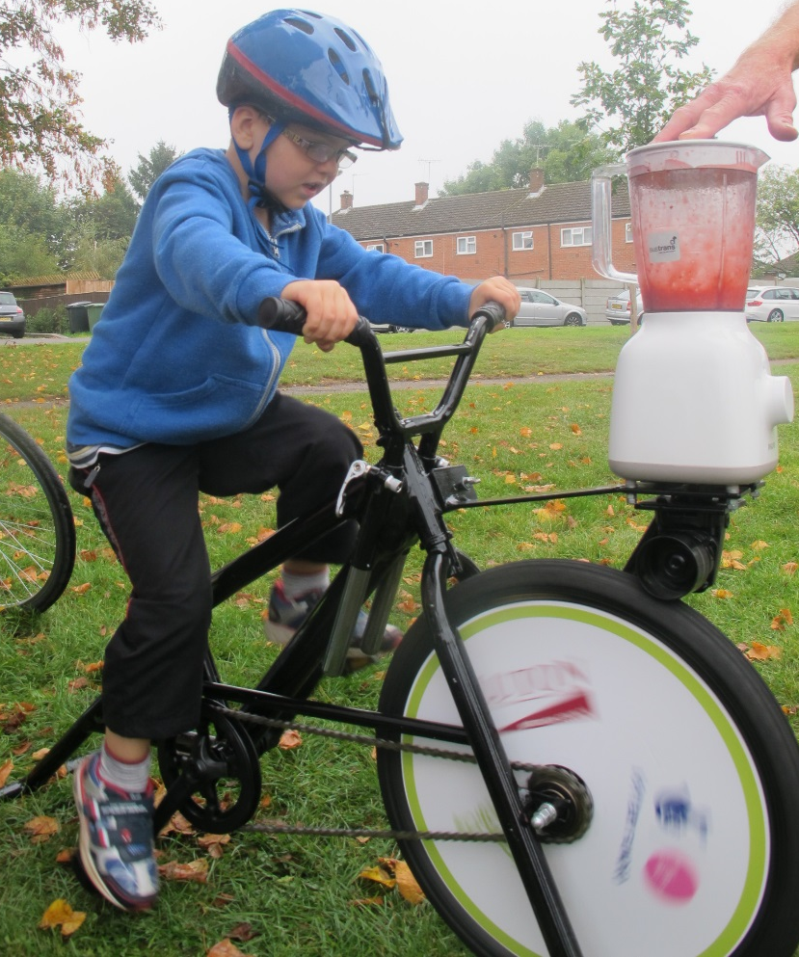

Smoothie Bike is a fantastic activity to encourage physical activity and healthy eating.

Required resources:
Smoothie Bike (per set up and safety checked)
Drinking cups
Ingredients- recipes can be researched by the children
Enthusiastic children

If you have any questions or worries please contact Richard Noon on 07901 880482 (richard.noon@sustrans.org.uk).

Running smoothie bike session:

- Check bike- look over the bike frame- looking for any cracks on the frame
Check that the wheel is tight- bolts shouldn’t be moveable with fingers, wheel should have no/very limited side to side movement.

2. Familiarise yourself with Risk assessment (below)
3. Get resources ready- Ingredients e.g. fruit juice, fruit, yoghurt, honey etc
Paper towels for spillages
Cups to drink from
Position the smoothie bike on a flat stable surface (paints and spare plates nearby)
4. Bring children in- Children to sit down a safe distance from bike
Discuss how session will run with children (include safety talk)
Order children in height order- this will save time later
5. Set height of seat for first children and close quick release (see pic) Check seat doesn’t move.
Adult- a), puts ingredients in blender jug UP TO 2 PINT MARK max. and ensures lid is closed securely
Child 1 b) child sits on bike and starts pedalling- do not allow child to stand up at any time
c), child pedals for about 30 seconds then,
Child 2 d), child 2 takes over for another 30 seconds. REPEAT with 2 or 3 more children
e), pour out smoothies to the children that have pedalled.
f), Go back to step 1 and repeat until all children have had a turn and a drink
Don’t forget to get loads of photos with smiling faces
Thoroughly wash blender with hot soapy water and dry with paper towel or leave to air dry. Unscrew the blender base taking care not to lose the rubber band gasket. Take extra care cleaning the sharp blades.
6. General clean- up of the area

7. Dismantle smoothie bike ready for return to Sustrans

Risk assessment
Risk | Severity/Likelihood (1,2,3) | Risk Rating (1-9) | Control measures
Trapped fingers  (during use) | 1/2 | 2 | - Pre session discussion  - Leaders to stay vigilant  - Wheel spokes covered
Total failure/  Mis-assembly | 2/1 | 2 | - Pre session check  - Leader to ensure all bolts are tight  - Leader to follow assembly instructions  - Leader to contact Bike It Officer
Bike falling to side | 2/1 | 2 | - Bike is very stable  - Leaders to ask children to remain seated
Seat wrong height | 1/2 | 2 | - Leaders to adjusting height for riders  - Leaders to ensure seat limit mark isn’t visible (see pic below)
Seat loose | 1,2 | 2 | - Leader to ensure seat is tight and quick release is done up (see pic below)
Falling off  Slipping off pedals | 1,2 | 2 | - Leader to ensure child is sitting  - Shoes and pedals to be dry
Moving parts hitting other user | 1,1 | 1 | - Users to remain seated until their turn
Slips and trips | 1,1 | 1 | - Leaders to ensure that floor is dry and clear of trip hazards
Trapped fingers (during assembly/disassembly) | 1,1 | 1 | - Leaders to assemble carefully, with support  - Keeping fingers clear during putting paint spinner on
Manual handling | 1,1 | 1 | - Follow standard manual handling practice
Mounting and dismounting | 1,1 | 1 | - Mount/dismount from side, leaders to offer support if needed

Assembly and disassembly:
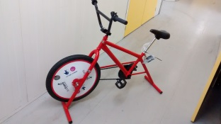

Left- smoothie bike ready to fit Blender attachment

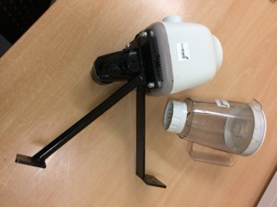
Right - Blender Attachment and Jug
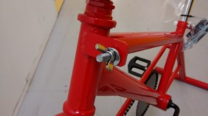
Unscrew wing nuts and take washers out (two of each), keep safe
With support, put Smoothie Attachment on bolts
Place washer on bolts followed by fly nuts, screw nuts in (see below)

L

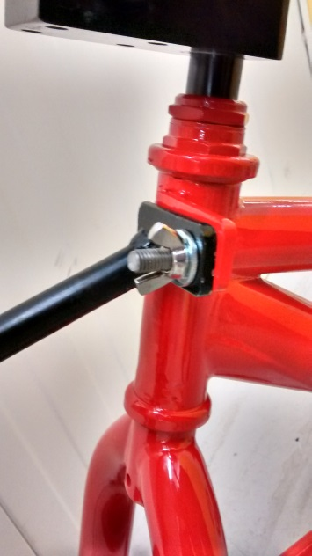
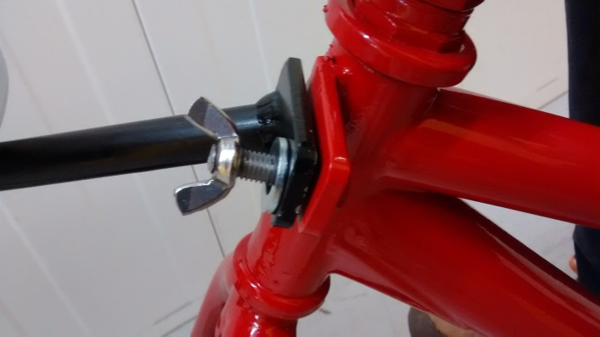

Ensure fly nuts are finger tight pressing against washer

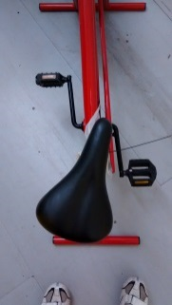
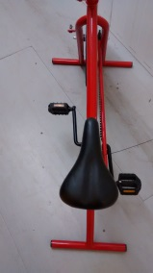
Ensure saddle (seat) is straight

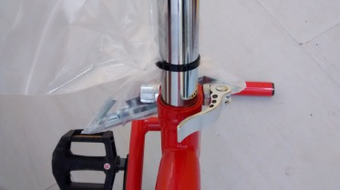

Ensure quick release is done up- should leave a slight Impression on hand

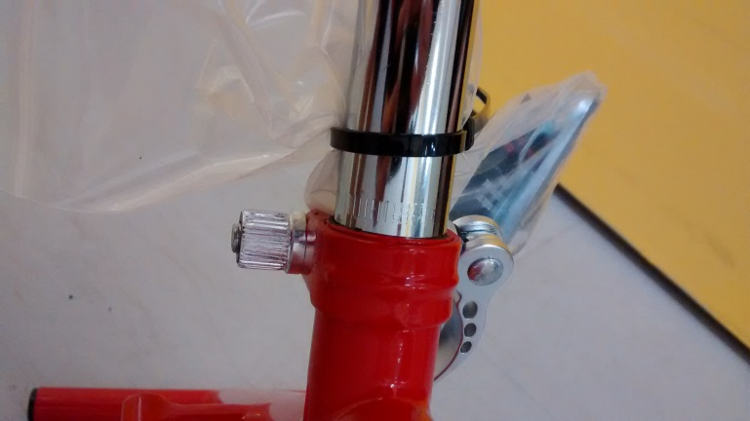
Check seat limiting mark, this shouldn’t be visible.

If you can see the marks lower the seat.
Disassembly
Clean any spillages on the blender or bike.
With one person supporting blender attachment undo fly nuts and washers.
Remove blender attachment and then replace fly nuts and washers on bolts.

