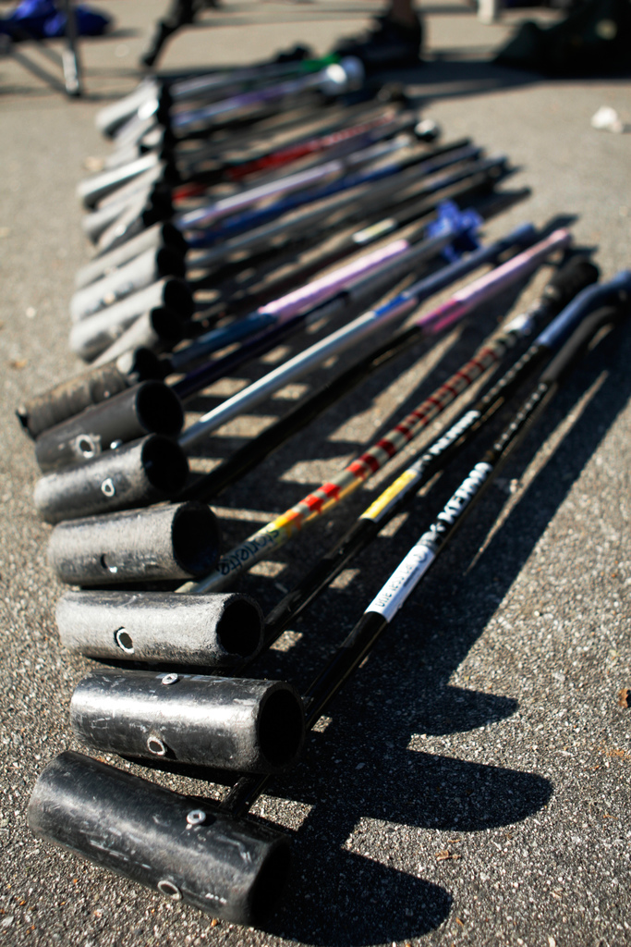
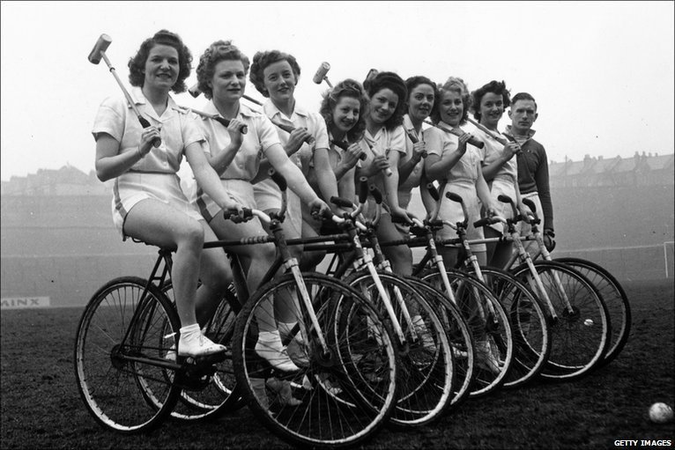
Bike Polo
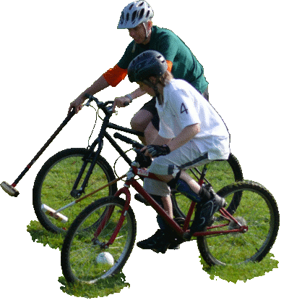

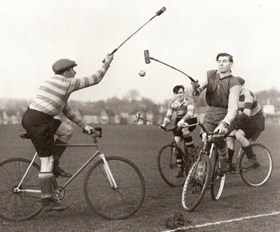

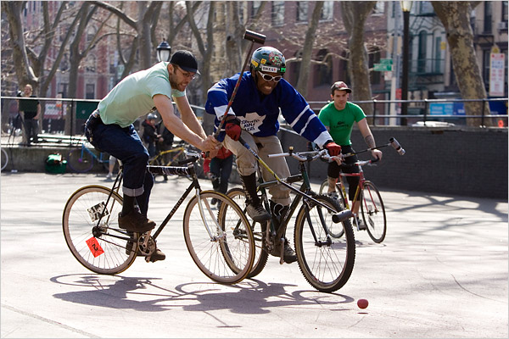
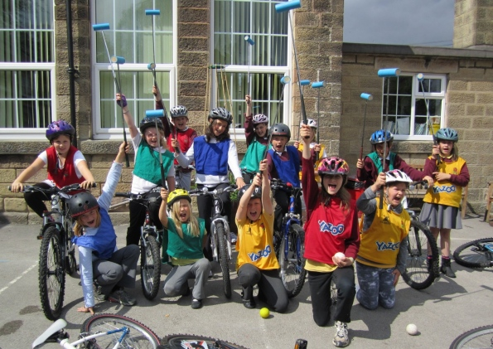

A Brief History

Bicycle Polo is a team sport, invented in County Wicklow, Ireland, in 1891 by retired cyclist, Richard J. Mecredy. The sport is similar to traditional polo, except that bicycles are used instead of horses. Towards the end of the 19th century the game reached Great Britain, USA and France.
Traditional Bicycle Polo is played in a rectangular grass field, 150 meters by 100 meters officially, unofficially whatever field is big enough. The ball used is of circumference 12-15 inches and the mallet is of length 1 meter.
In recent years, an alternate form of the game known as "Hardcourt Bike Polo" or "Urban Bike Polo" has grown in popularity. Generally this is a faster game with 3 members on a team, no substitutions, and all members are on the court at all times. This less formal variation is played on tennis courts, street hockey rinks, or whatever other surfaces are available. The rules vary slightly by city. A Street Hockey ball is used and matches are played until one team scores 5 points.

http://www.miamibikepolo.com/what-is-bike-polo/

Getting started

Equipment:

A Bike - You can ride any bicycle you like, handlebars must be plugged and you must have at least one brake. A fixed drive counts as a brake.
A Mallet – Bike It Mallets can be provided. Other mallets if used should not have heads made out of metal or any material that is sharp and/or could obviously chip, shatter or splinter. The handle end of the mallet shaft must be securely plugged.
Helmets are recommended and gloves are useful for grip and to protect your hands if to come off.

Basic rules:
- Don’t put your foot down
- Score with the small end of the mallet head
- Contact should be restricted to ‘like for like’ i.e. body to body, bike to bike, mallet to mallet
- First to five points wins (or whoever has the most goals when the time runs out)
Playing area:

Bike polo can be played on any hard surfaced area or on short cut grass on a dry firm surface. Typical pitches are rectangular and start at 20m x10m, though are usually bigger. Playing area needs to be free of obstacles and debris. Cones can be used to mark the pitch boundary and goals.

Video Clip:

See how the experts do it http://news.bbc.co.uk/1/hi/uk/8177503.stm

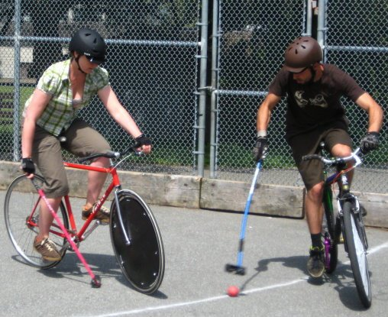
Skills and Activities
The activities given here will help the riders to develop the skills needed to be able to play a game of Bike Polo. The activities get progressively more complex and can be worked through in one go or over a number of sessions. How fast you get through the activities depends on the starting level of the riders.
Additional equipment needed:
- Cones
- Balls
- Whistle

- Start with slalom

- Slalom with right hand off handlebars [Explain why we use left hand to steer/brake]

- Number riders and get them to cycle around in a circle and as their number is shouted out they rider all the way around the group to their original place. [Explain the importance of working as a group and keeping gaps between riders & the gap for the circling rider left open]

- Cycle around with one hand off and get them all to slow right down and then accelerate away again [Explain the importance of gear selection and using 2 o’clock position to start]

- Give riders a mallet[don’t raise it above shoulder height], get them to cycle down the slalom with it in the right hand

- Get riders ,one by one , to cycle towards you, roll the ball towards them and get them to hit it back to you[emphasize that its not about big power shots but accurately making contact with the ball]

- Explain Tapping Out (if your foot touches the floor during play players will need to tap their mallet on the edge of one or either of the long sides of the pitch before resuming play).
Get riders to cycle towards you, stop at a designated cone, lean on mallet, set off again and hit a rolled ball back to you.
Add any other fast/slow speed activities here

- Set up a goal with cones, stand behind it, get riders to cycle towards it and roll ball towards them to take a shot on goal.(this activity could be varied by getting riders to come in from different angles.

- Split group into two and put the ball at a point equidistant from both groups. On the whistle they race towards the ball and try to make contact with the ball before their opponent. [Reinforce importance of the 2o’clock start position, gear selection and that they must pass right shoulder to right shoulder with opponent].

- Dribbling skills-Introduce use of the mallet, the long side of the mallet is for dribbling and the head is for taking shots with. Set up goal (as above) but add a set of cones. The rider cycles towards you, roll the ball to them, they dribble it up to the first set of cones, then shoot at the goal.

- Get riders to dribble through a course set of cones offset from each other

- Get riders to cycle around within the court and shout out the name of another player then pass the ball to them (this activity builds on their dribbling skills and manoeuvring around other riders).

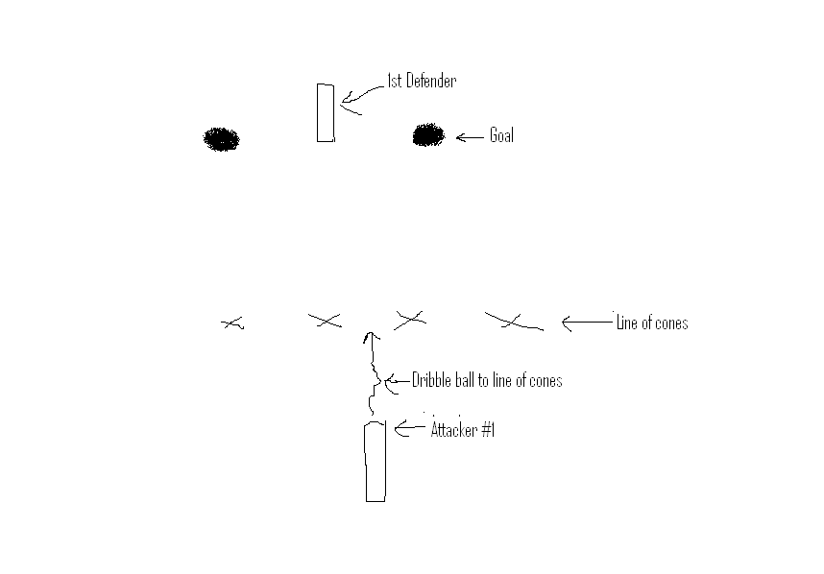
- Another drill is as above but with a defender on the goal line who can only move once the opponent has passed the line of cones. The attacker dribbles the ball to the cones than tries to score, (see below). You can develop a variation of this by adding a second attacker who starts off to one side and feeds the ball to their team mate while the defender tries to stop any shots on goal.

The Official Rules:
These are the latest rules for the European Hardcourt Polo Championships hosted by London in August 2009. They are designed to represent the way the game is already played, and to allow disuputes to be resolved.
- Bike:
-You can ride any bicycle you like, handlebars must be plugged and you must have at least one brake. A fixed drive train counts as a brake.
-Wheel covers are allowed but any defense oriented frame additions are not.
- Mallets:
-Referee will have the final say in mallet safety.
-Mallet heads cannot be made of metal or any material that is sharp and/or could obviously chip, shatter or splinter.
-The handle end of the mallet shaft must be securely plugged.
- Start of the Game:
-Players will start at their goal lines with the ball placed at centre court. At the referee’s shout of ‘3,2,1, Go!’ any or all players from either or both teams can charge the ball for possession.
- Play of the Ball:
-Play of the ball is considered to be anything directly related with the process of blocking possession, gaining possession, passing, traveling with and putting the ball into your opponent’s goal.
- Scoring:
-Goals will have width, height and depth restrictions. They will be netted with no traveling through the goal.
- Shuffles & Hits:
A ‘Hit’ is only made from the end of an player’s mallet. A ‘Shuffle’ is hitting the ball with the broadside of the mallet or the shaft of the mallet.
-An offensive shuffle does not count as a goal. If the ball is shuffled into the goal by the offensive team, play continues uninterrupted. The offensive team can take control of the ball but cannot score until any second player has handled the ball.
-If a team puts the ball into their own goal, it is a goal for the opposing team.
-An offensive hit directly into the goal is a goal.
- Reflection & Deflection:
Reflection means a hit coming off of a offensive player’s bike or person whether purposeful or accidental.
Deflection means a hit coming off of a defensive player’s bike or person whether purposeful or accidental.
-If an offensive player adds momentum or direction purposefully to a reflection it is not a goal. All other reflections are goals.
-Deflections, not starting from an offensive shuffle, count as a goal for the offensive team.
- Ball Joint:
Cupping and/or Scooping the ball with an open end of the mallet.
-It is legal to travel with the ball using this style of carrying the ball but you cannot score with it.
- After a goal is scored/resetting the game:
-After a goal is scored, the scoring team must return to their own goal area and cannot come back across center court until the ball and/or any player of the conceding team has come past center court. Goal area may depend on court. This will be clearly marked.
-The conceding team takes possession of the ball. No conceding player with or without the ball can then pass half court until at least two players of the scoring team have returned to their goal area, one of these players can be a ‘goalie’ who was already in the goal area. In the case of the scoring team taking undue time returning to their goal, the referee can call ‘game on’.
-In case of the ball ricocheting from the goal past half court, the conceding team must possess the ball before scoring team may touch it.
-A player is not required to tap out for a foot-down after a goal has been scored but must return to their goal area.
- Fouls:
-Players must not touch the floor with their feet. Touching the wall or barrier with your feet is allowed; feet must not touch the floor. Each time a player does foot-down, that player is out of play and may not play the ball until they touch either sideline at center court. The player must immediately tap-out and not purposefully obstruct play. Intentionally obstructing play after foot-down will be considered a strong penalty. A possible goal that is blocked by a player out of play due to foot-down is not a goal.
-Throwing your mallet is not allowed at any time and will be considered a strong penalty.
- T-bone’ or charging. Intentional, forward moving bike contact that is perpendicular or near perpendicular (resulting in a maneuver similar in shape to a letter ‘T’) will be considered a strong penalty.
-Overly aggressive behavior such as grabbing, pushing, punching with hands, pushing or kicking with feet, and headbutting will be considered a strong penalty.
- “Like” contact that is allowed:
-Non-aggressive Body to body, mallet to mallet, and bike to bike. Apart from the fouls listed above.
-Contact is only permitted within the play of the ball. Contact away from the play of the ball can result in a tap-out or penalty.
- Non-like contact that is allowed:
-Ball to body, mallet or bike.
-Body to ball is allowed if you are sat in the saddle, feet on the pedals, hand holding mallet, other hand on bars. You cannot intentionally restrain, nor add momentum to the ball with your body. This can result in the ref calling a tap-out.
-If the ball becomes trapped within your bike or person play continues but please be aware that any legal play towards your bike or person will be considered as play towards the ball and therefore legal.
- Time outs:
- Can be called by a player only after a goal is scored.
- May be called in order to tend to physical injury.
- May be called in order to tend to a mechanical failure.
- Will be limited to five minutes, one per game per team.
- Refs can call and extend injury and mechanical failure timeouts over and above these rules, but is under no obligation. The ref can also call game-on if the timeout is unnecessary.
- Referees:
At least two refs will be appointed per game. They will be informed and assigned ahead of time. Refs will:
- Determine what is and is not a goal.
- Determine what is and is not a foul that can result in a penalty and what the penalty is for such foul.
- Correct the goal if it is moved.
- Keep track of score. Score must be called out after every goal.
- Keep track of time.
- Call injury time outs for major injuries.
- Provide an extra ball at point of exit if the ball is knocked out of play.
- Have the final word.
- Players have the responsibility to keep legal play on the court. If they are unable to the ref will decide on an appropriate penalty:
Penalties can be:
* Tap out at either the sidelines or either goal line.
* Do a lap around the court before re-entering play
* Give possession of the ball over to the opposing team.
* Be removed from the game until the next goal is scored or for a set time or even permanently. Timed games; 10 minute game=30 second penalty, 15 minutes = 45 seconds, over 20 minutes = 1 minute.
* In extreme cases any form of public humiliation can be considered proper punishment for offenders.

http://www.bikepolo.org.uk/rules/

